Minio as File Storage for Beszel

MinIO Deployment with Docker Compose (Integrated with Beszel)
This document describes how to deploy MinIO using Docker Compose in a production-ready manner and integrate it with Beszel Monitoring Tool for S3-compatible object storage.

1. Architecture Overview
• MinIO runs as a container.
• Beszel runs as a container.
• Both containers must share the same Docker network.
• MinIO Ports: 9000 (S3 API), 9001 (Web Console).

2. Production Considerations
• Do NOT use default credentials.
• Use environment variables or .env file.
• Use persistent storage.
• Enable TLS (HTTPS) in production.
• Restrict public port exposure if internal-only deployment.

3. Recommended Directory Structure
project-root/
│
├── docker-compose.yaml
├── .env
└── minio-data/

4. Example .env File
MINIO_ROOT_USER=minioadmin
MINIO_ROOT_PASSWORD=minioadmin123
MINIO_SERVER_URL=http://minio:9000

5. Production Docker Compose File
version: "3.8"
services:
minio:
image: minio/minio:latest
container_name: minio
restart: unless-stopped
command: server /data --console-address ":9001"
env_file:
- .env
ports:
- "9000:9000"
- "9001:9001"
volumes:
- ./minio-data:/data
healthcheck:
test: ["CMD", "curl", "-f", "http://localhost:9000/minio/health/live"]
interval: 30s
timeout: 20s
retries: 3
networks:
- monitoring-system_brezel-net
networks:
monitoring-system_brezel-net:
external: true

6. Deployment Steps
1. Ensure Docker network exists:
docker network create monitoring-system_brezel-net
2. Start services:
docker compose up -d
3. Verify container status:
docker ps

7. Create Bucket
Option A: Use Web Console at http://<server-ip>:9001 and create bucket 'beszel'.
Option B: Use MinIO client (mc) inside container to create bucket.

8. Beszel Configuration
Go to the Beszel URL for the file storage configuration page and update info as below.
Endpoint: http://minio:9000 Bucket: beszel
Region: local Access Key: from .env
Access Key: from .env Secret Key: from .env
Force Path Style: Enabled
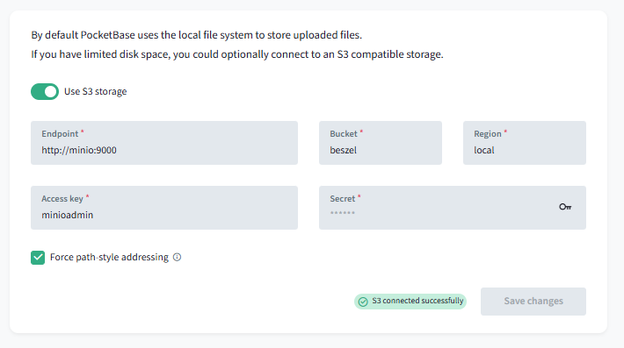

Minio as Backup Storage for Beszel

Go to the Beszel URL (http://localhost:8080/_/#/settings/backups) for the file storage configuration page and update info as below.
Endpoint: http://minio:9000 Bucket: beszel
Region: local Access Key: from .env
Access Key: from .env Secret Key: from .env
Force Path Style: Enabled
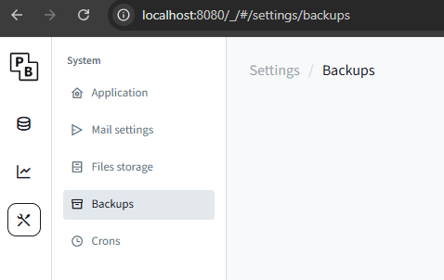
Update values as follows:
